NAME: MEKALA ANUSHA

- Sales Analysis by Region: Which region has the highest total sales?
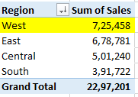
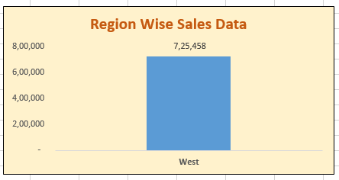

Explanation: In Region wise sales the West region as highest sales.

2. Profit Trends: Which product categories and sub-categories are the most profitable?
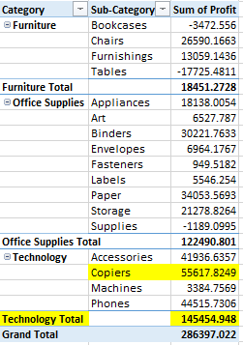

Explanation:
In Category Technology has most profitable.
In Sub Category Copiers has most profitable.

3. Discount Impact: What is the relationship between discount rates and profit margins? (Profit margin = Profit/sales)
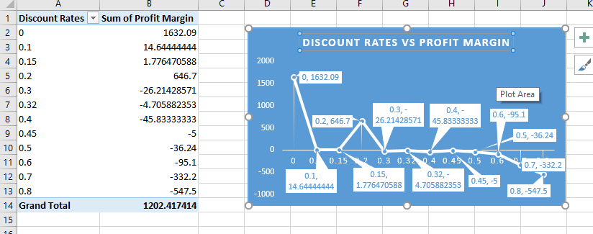
Explanation:
When Discount rates are less profit margin will be more.
When Discount rates are more profit margin will be less.

4. Shipping Mode Efficiency: Which shipping mode is used most often, and how does it correlate with profits? (count of shipping mode, which ship mode is giving highest profit)

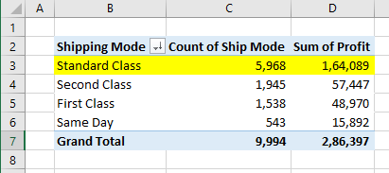

Explanation:

In shipping mode Standard Class was used most often and standard class as highest profit. It means which had more often used have more profit.

- Top Customers: Who are the top 5 customers by total sales?
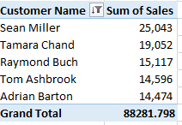

Explanation:
As per sales data, the above are the Top 5 customers.

- Product Performance: Identify the top 10 products by sales volume.

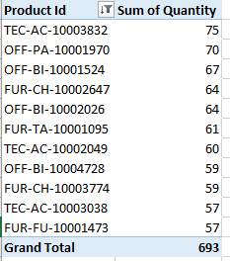

Explanation:
As per sales data, the above are the Top 10 products in sales volume.

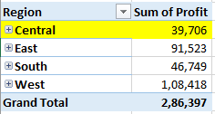
7. Regional Profitability: Which region has the lowest profitability, and what might be contributing to this? (find out which products are being sold highest in this region and whether these products have a high profit margin)

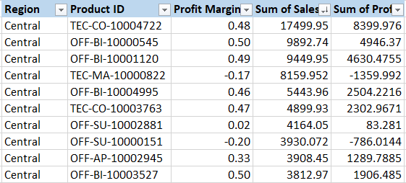

Explanation:
The Central Region has lowest profitability.
In Central Region Some products with high sales have negative profit, it impacting to lowest profitability.
The above products are the highest Sales in the central region.
For the above products profit margin is high.

8. Customer Segment Analysis: Which customer segment based on City
Contributes the most to overall sales and profits?
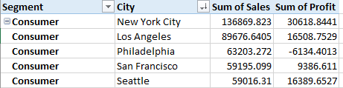

Explanation: In Consumer segment New York City contributes the most to overall sales and profits.

- Loss Leaders: Identify product categories with high sales but negative profits.
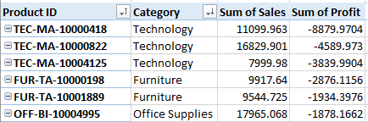

Explanation:

TEC-MA-10000418 – This product Id in technology category with highest sales and negative profit.

10. Insights Dashboard: Generate key insights from the data set and create a Comprehensive Excel dashboard to visualize them.

